Echo
show text and variable value on terminal



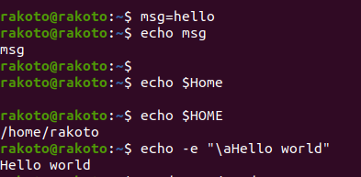

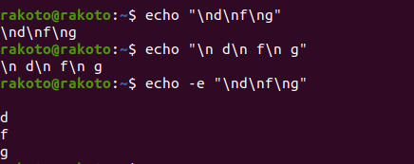

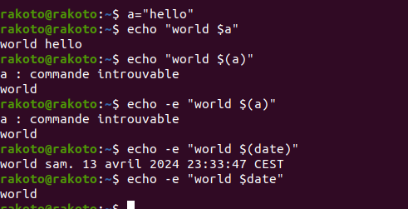

grep
searching text within files

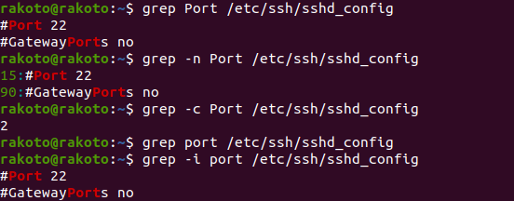
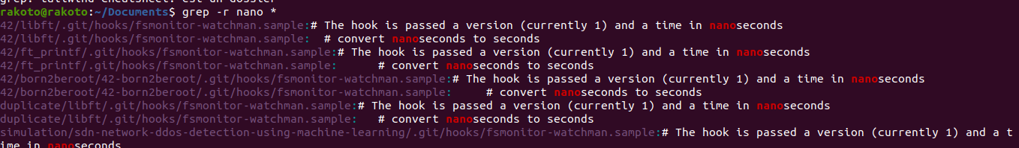

-i to ignore case
-v to reverse (instead of searching the line containing the word it will return all line that not contaning it
-r search recurcivly the word in each file instead the directory given
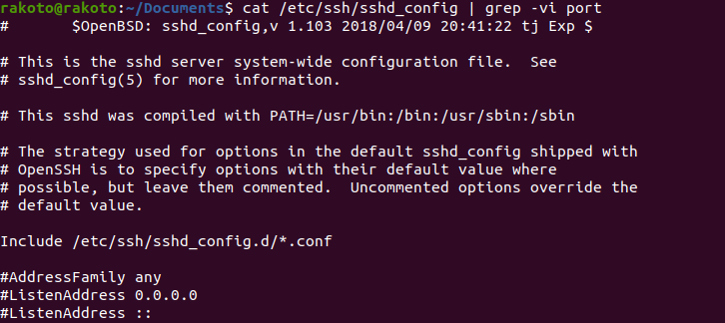
cut
remove section from line


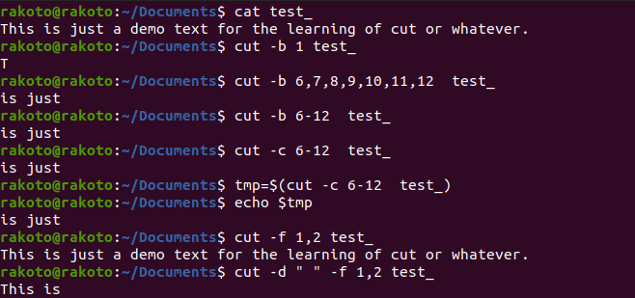
cut needs delimiter -d when using it with -f for field
-b stands for bit

awk
awk - pattern scanning and text processing langage (filter

awk ‘command’ file

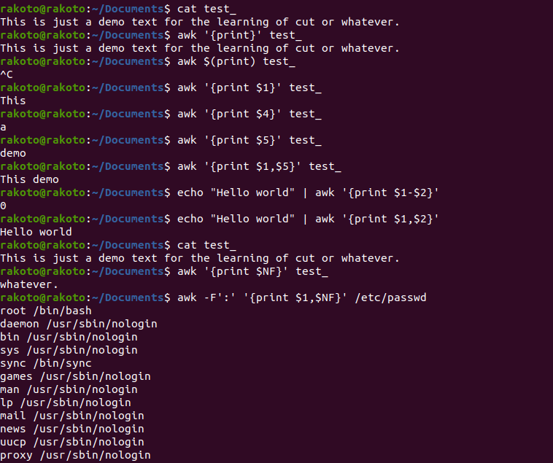
NF:end of file
-F to set delimiter

